CENWP-OD-B 18 Dec 2024

MEMORANDUM FOR THE RECORD

SUBJECT: 24BON067 MFR Cascades Island Fishway Coho Salmon Mortality

On the morning of 18 December 2024, Project Biologists discovered one adult coho mortality submerged in the water of the fish ladder while performing fish salvage operations. The fish was measured, scanned for PIT tags, inspected, and returned to the river.

- Species – Coho Salmon (Oncorhynchus kisutch)
- Origin – Unknown
- Length – approximately 71 cm total length
- Marks and tags – Adipose fin clipped, no PIT detected
- Marks and Injuries found on carcass – Decomposed
- Cause and Time of Death – Unknown
- Future and Preventative Measures – N/A

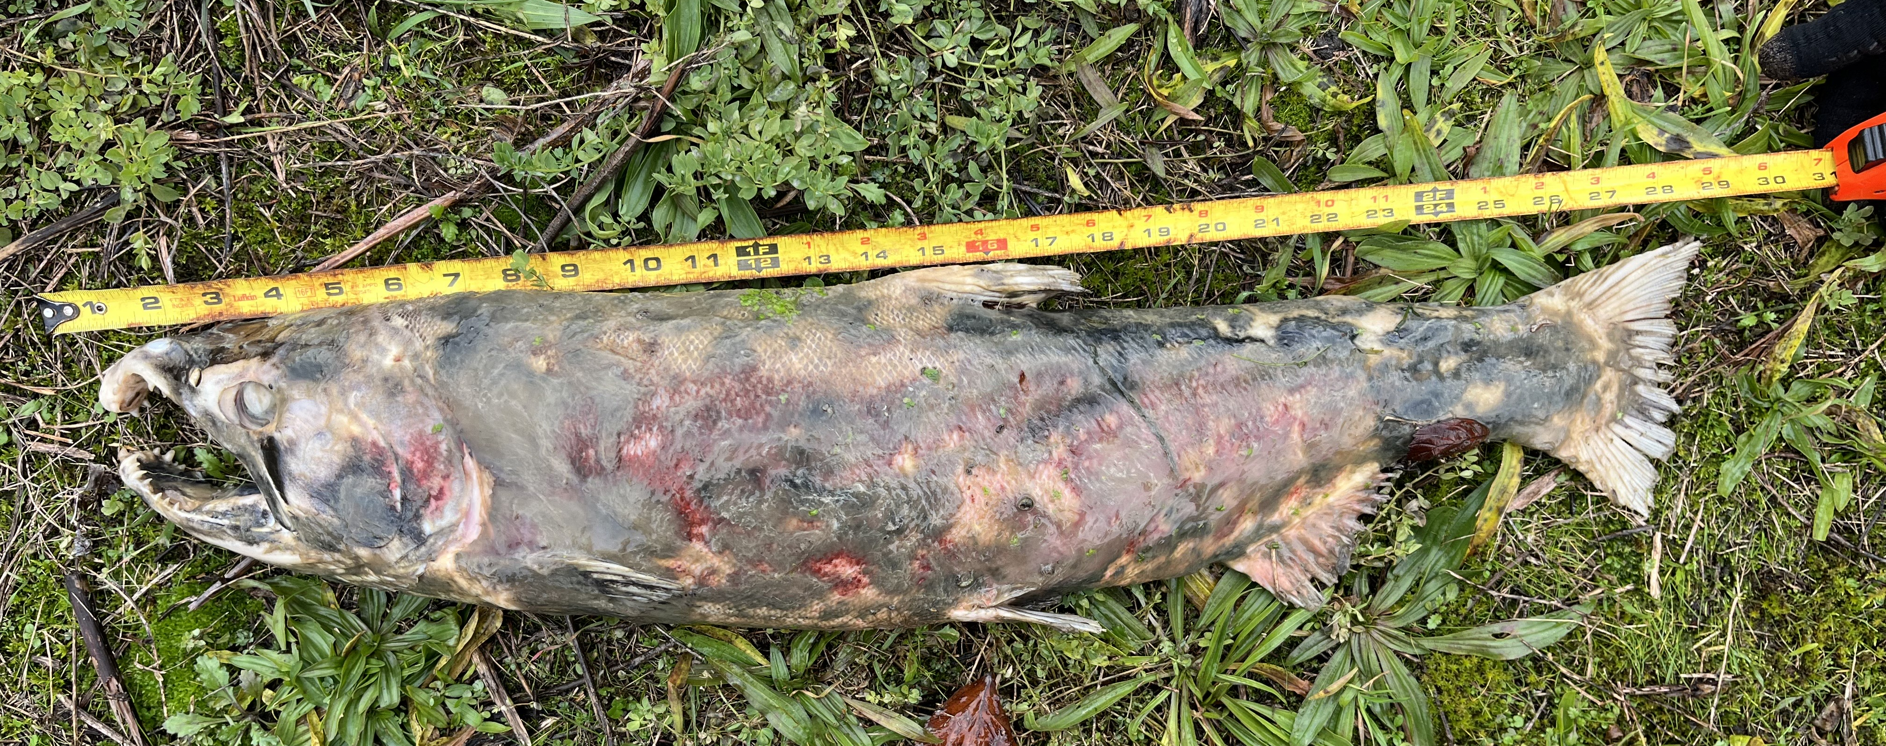

Sincerely,
Bonneville Project Fisheries

